BIT 4107 – Mobile Application Development
ENHANCED PROFESSIONAL STUDENT LOGBOOK
Student Name: CHARLES MURIUKI
Admission Number: BIT/2024/43959
School/Faculty: COMPUTING AND INFORMATICS
Programme: BACHELOR OF SCIENCE INFORMATION TECHNOLOGY
Academic Year: YEAR 4
Semester: 1
Lecturer: MR MICHAEL NYORO
Phone Number: 0796800979

Instructions
This logbook is used to document weekly learning activities, practical exercises, skills acquired, challenges encountered, solutions applied, and reflections. Students should complete all sections every week.
Each week to follow remarks in week 1 section.

Autogenerated Table of content

Week 1: Introduction to Mobile Application Development

Practical Activities Undertaken
only screenshots needed and labeling
Screenshots/Evidence Attached (Yes/No)

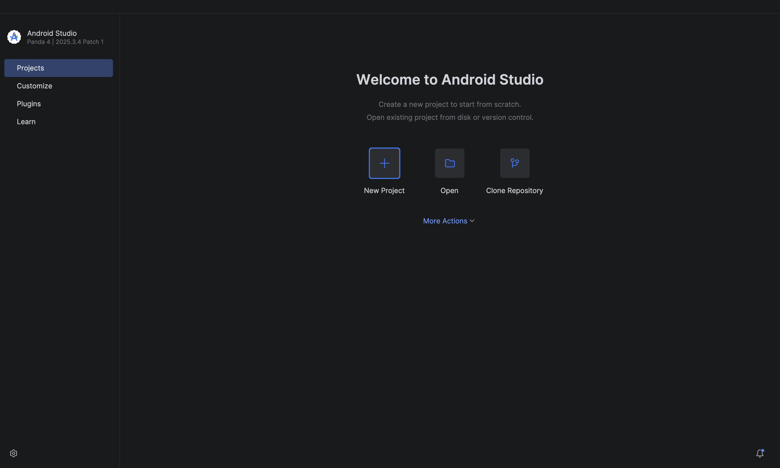
Tools/Software Used

Fig 1.1: Android studio installation
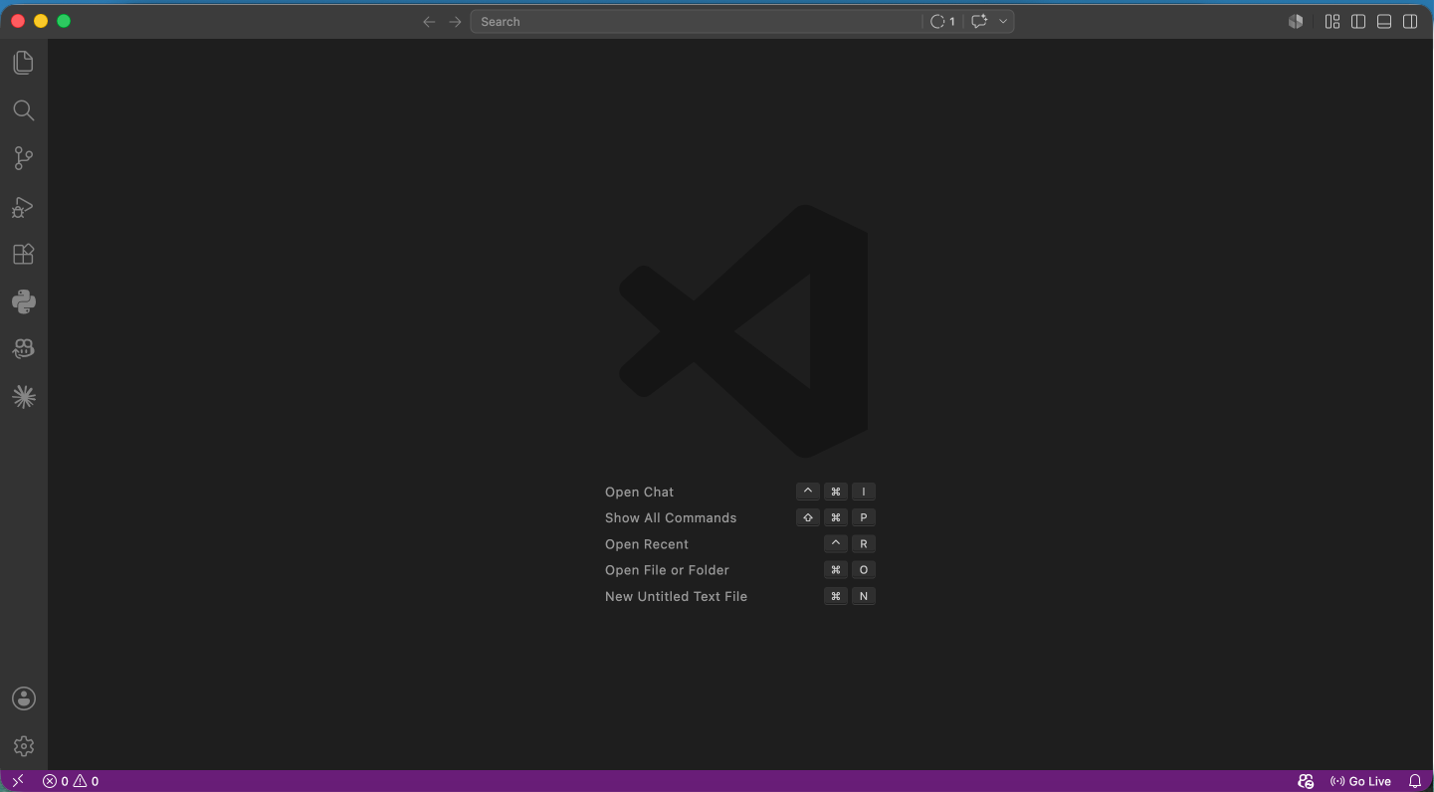

Fig 1.2: VSCode installation
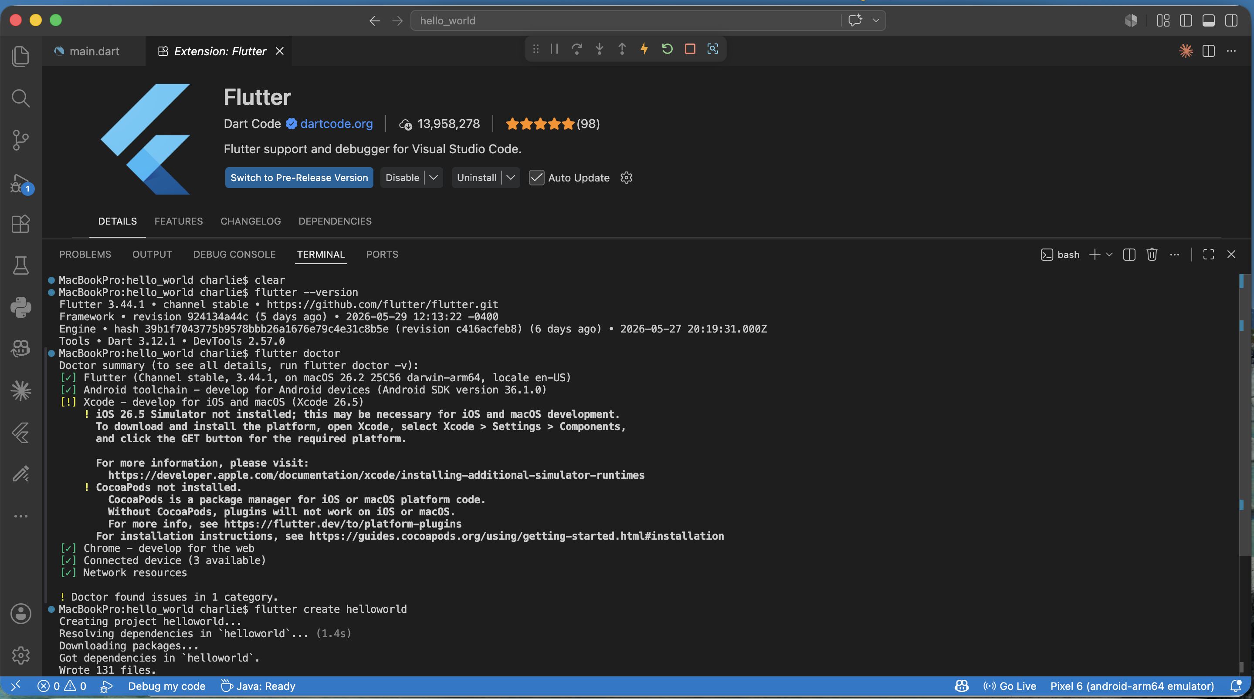

Fig 1.3: Flutter and Flutter extension installation

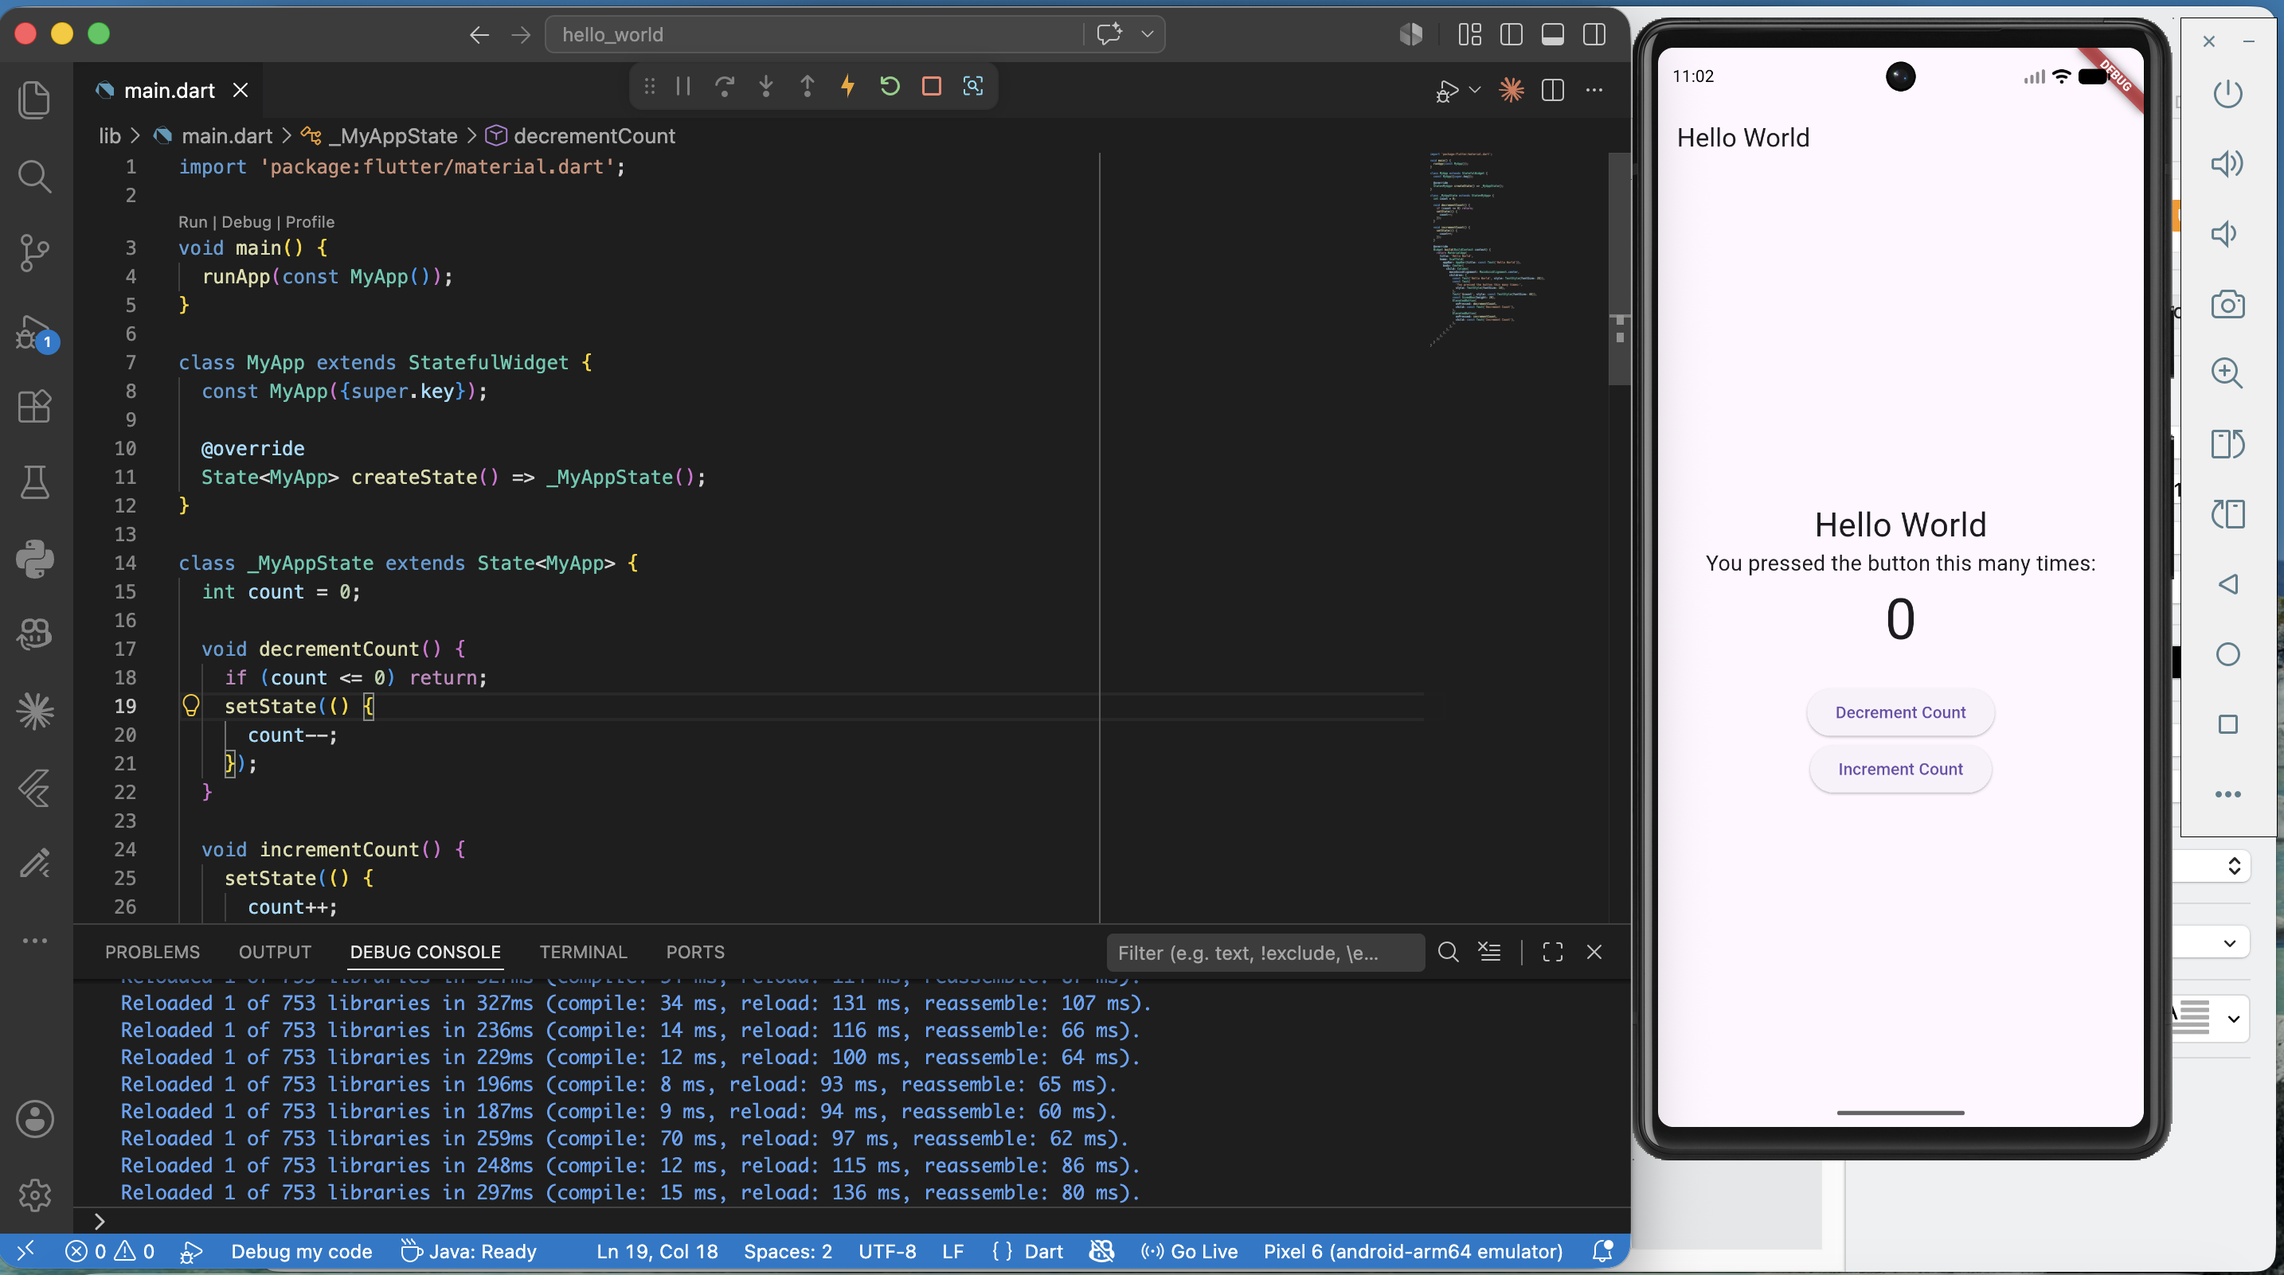

Fig 1.4: Hello world counter app

Personal Reflection
Flutter/dart appears to have a potentially good learning curve based on previous programming knowledge.

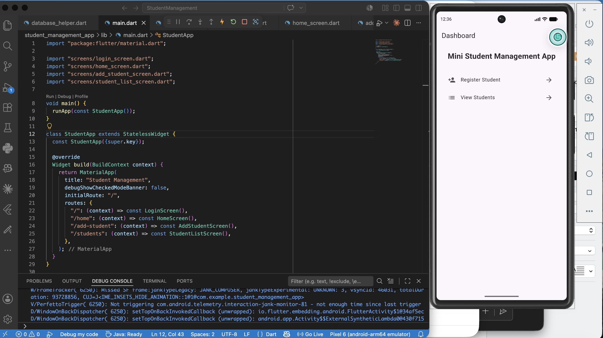
Week 2: Mobile Development Environment
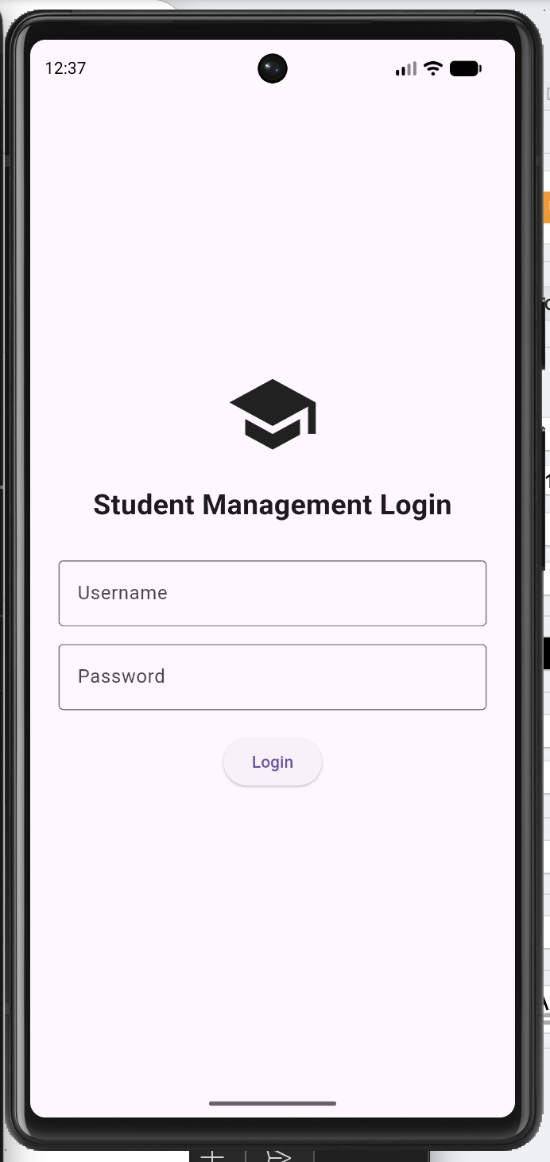
Fig 2.1: Mini student management app

Fig 2.2: Admin Login page
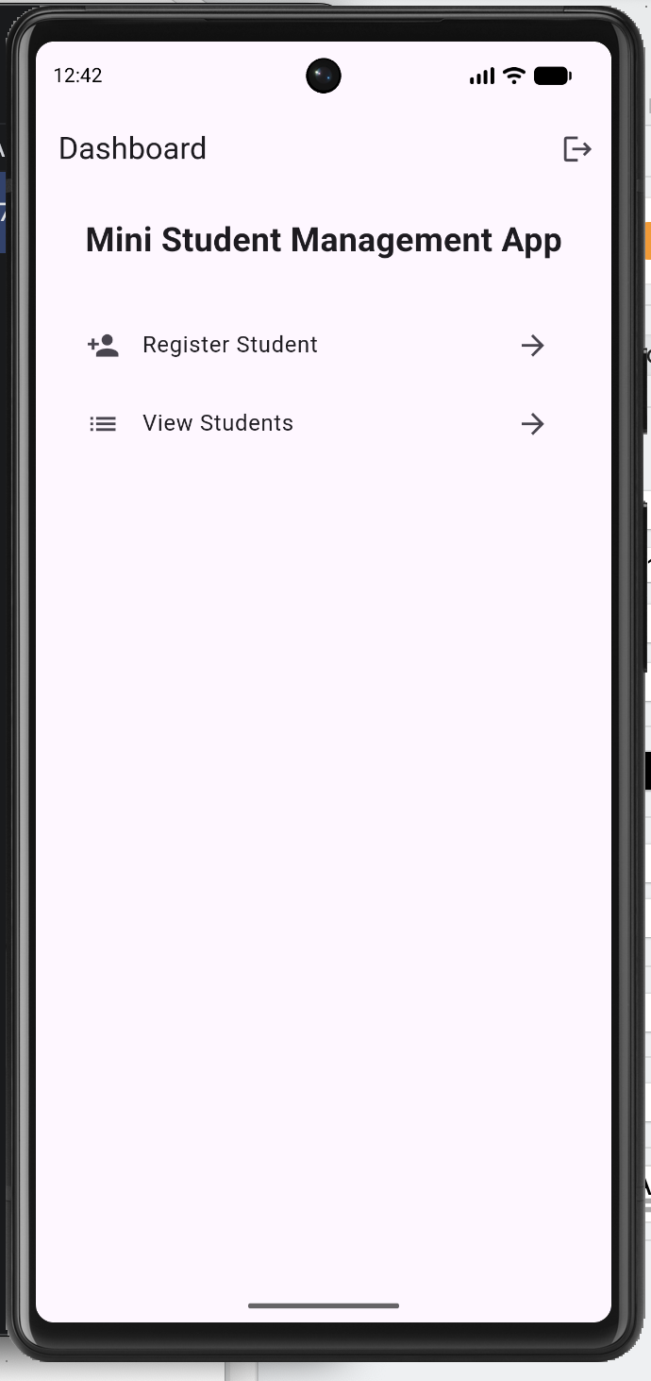

Fig 2.3: Homepage

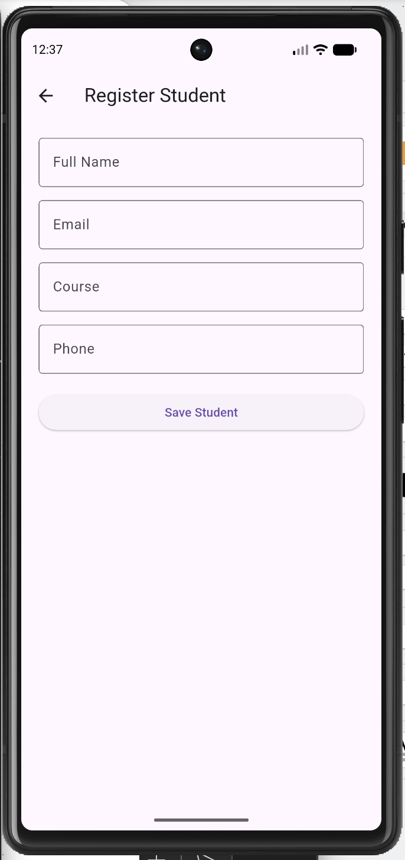

Fig 2.4: Register student

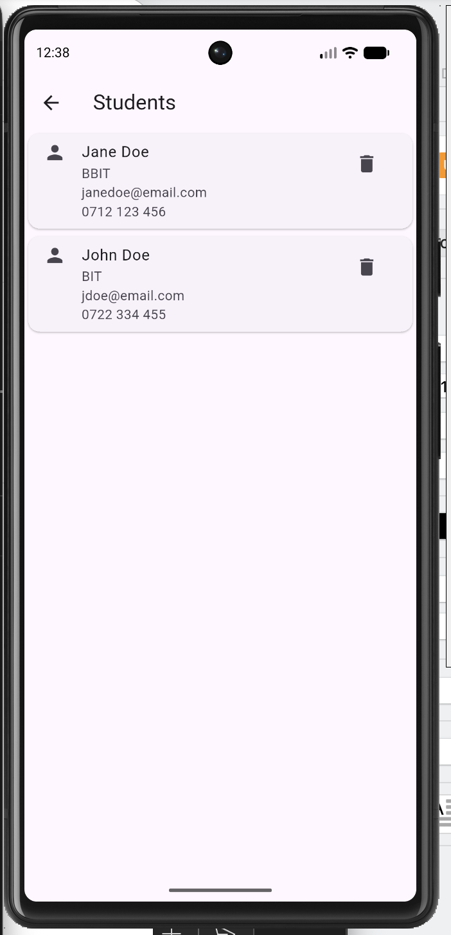

Fig 2.5: List students

Personal Reflection
Interesting insights on persisting data permanently on a local database.

Week 3: User Interface Design

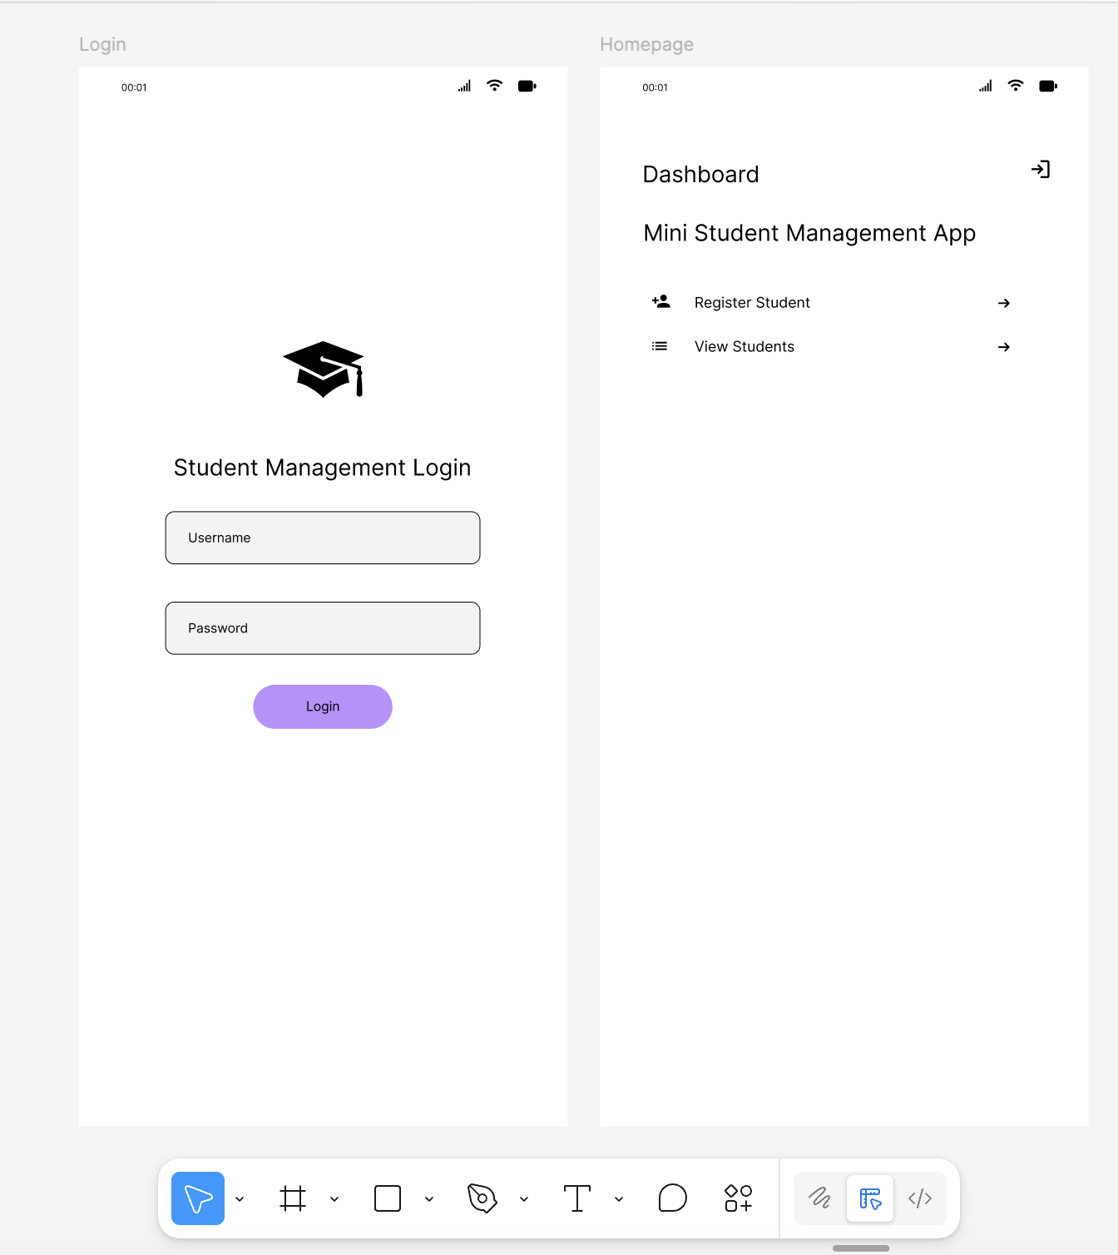

Fig 3.1: Figma - Login and Homepage wireframes

Fig 3.2: Figma - Register and List Students wireframes
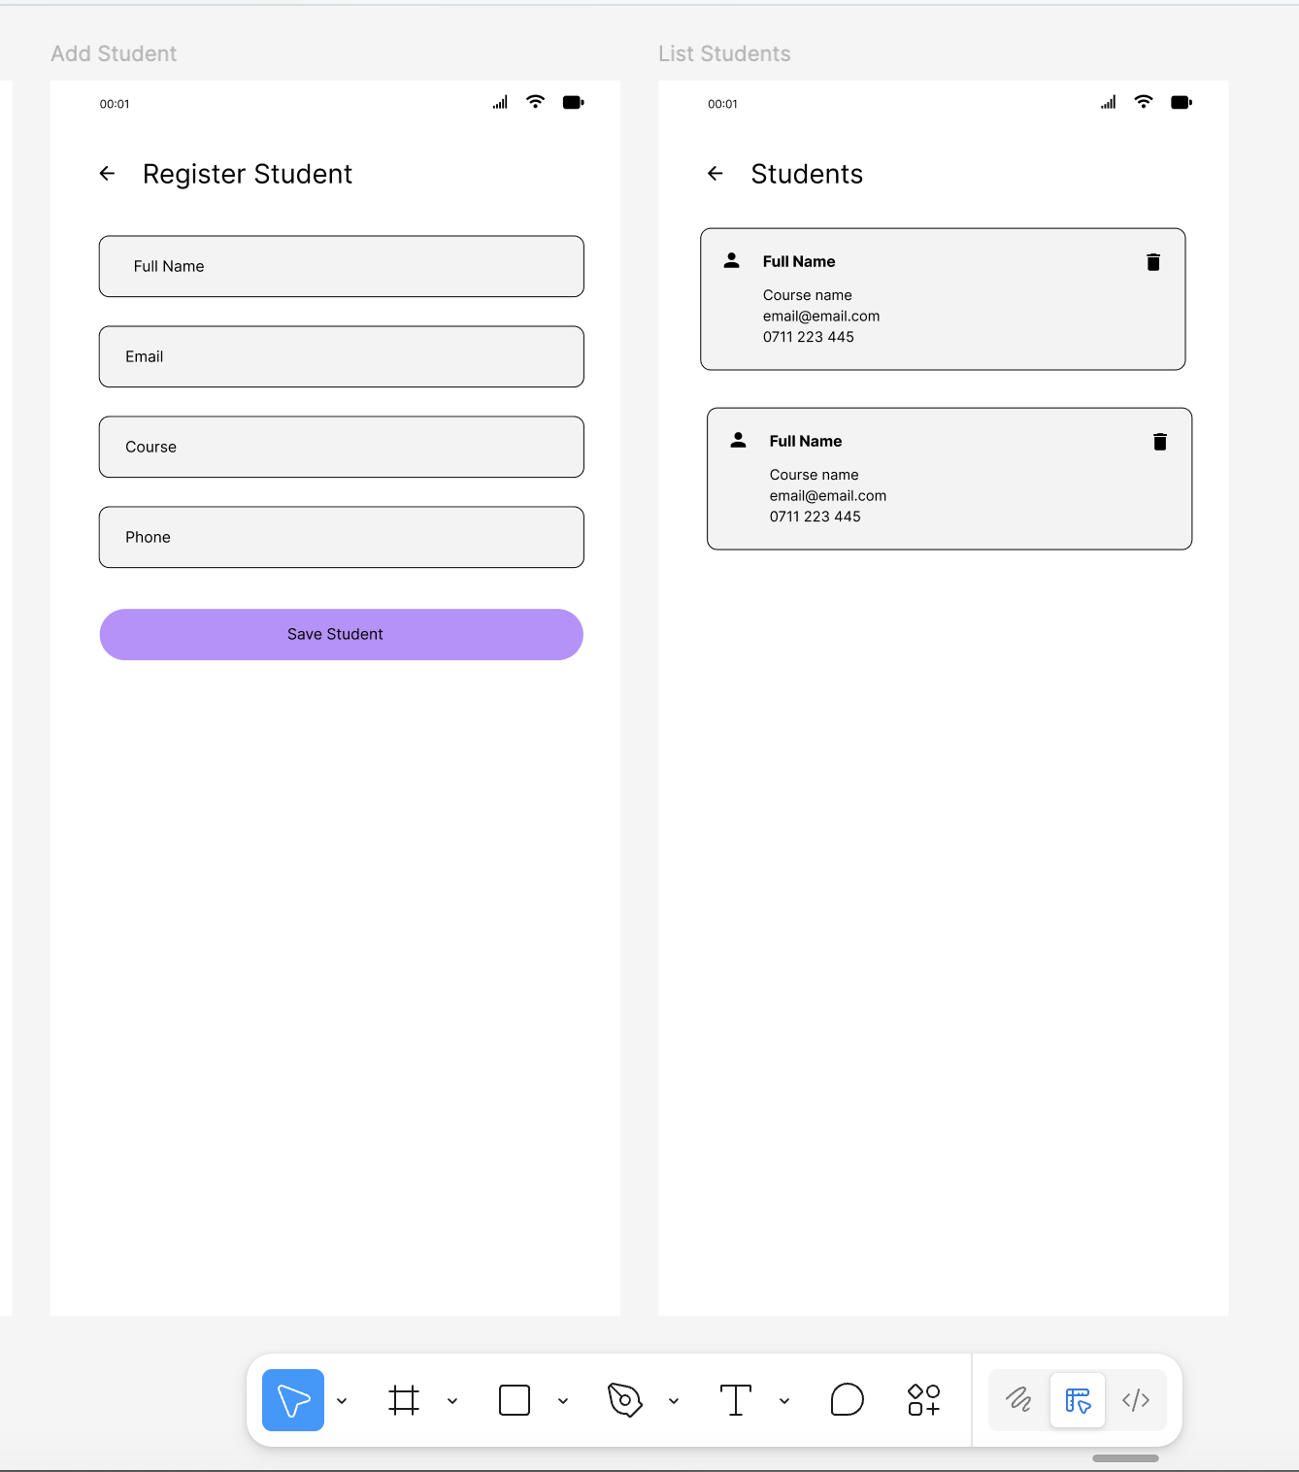
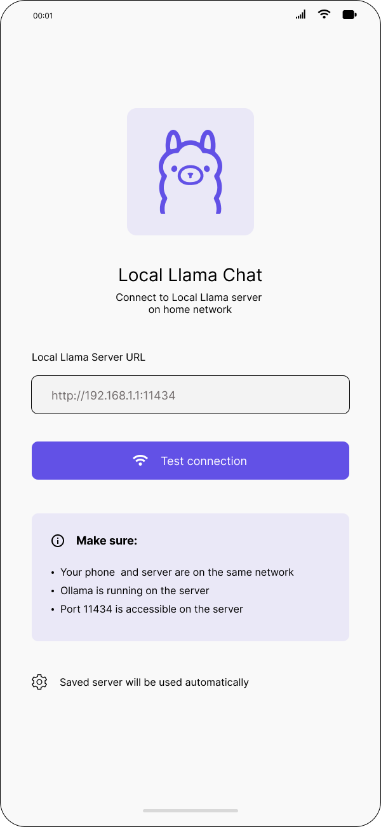
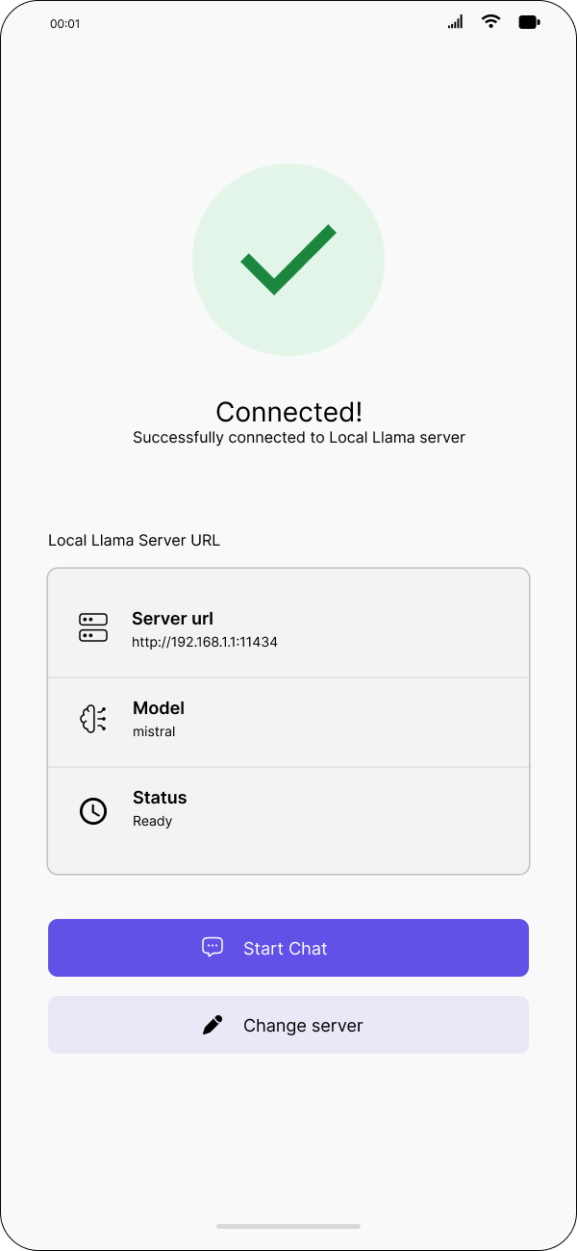

Fig 3.3: Figma - Local Llama Homepage Wireframe

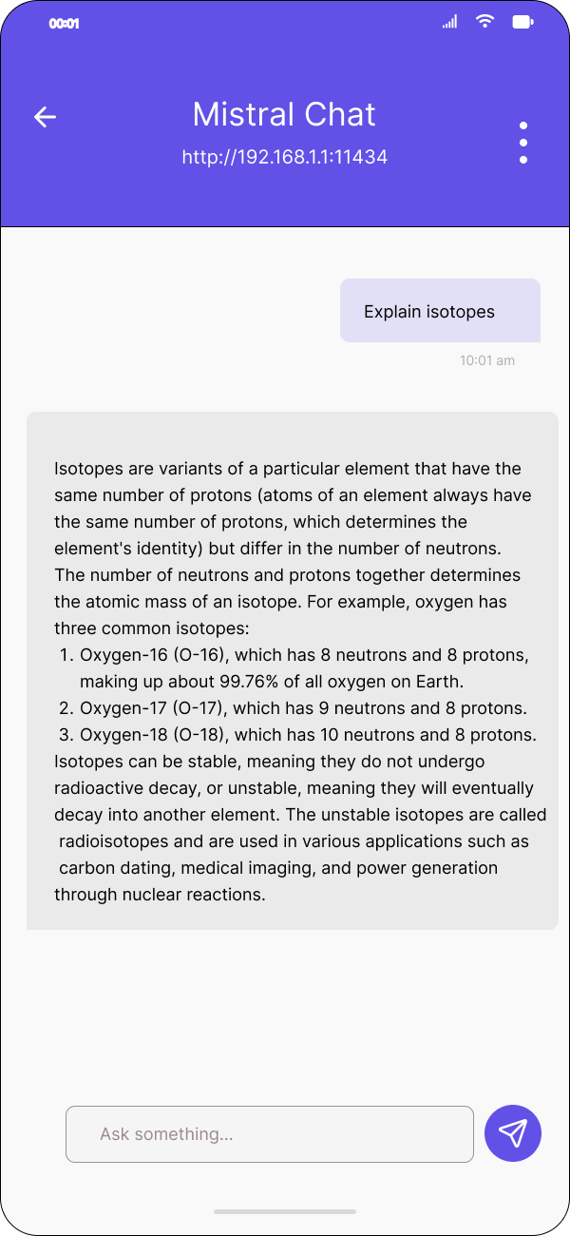
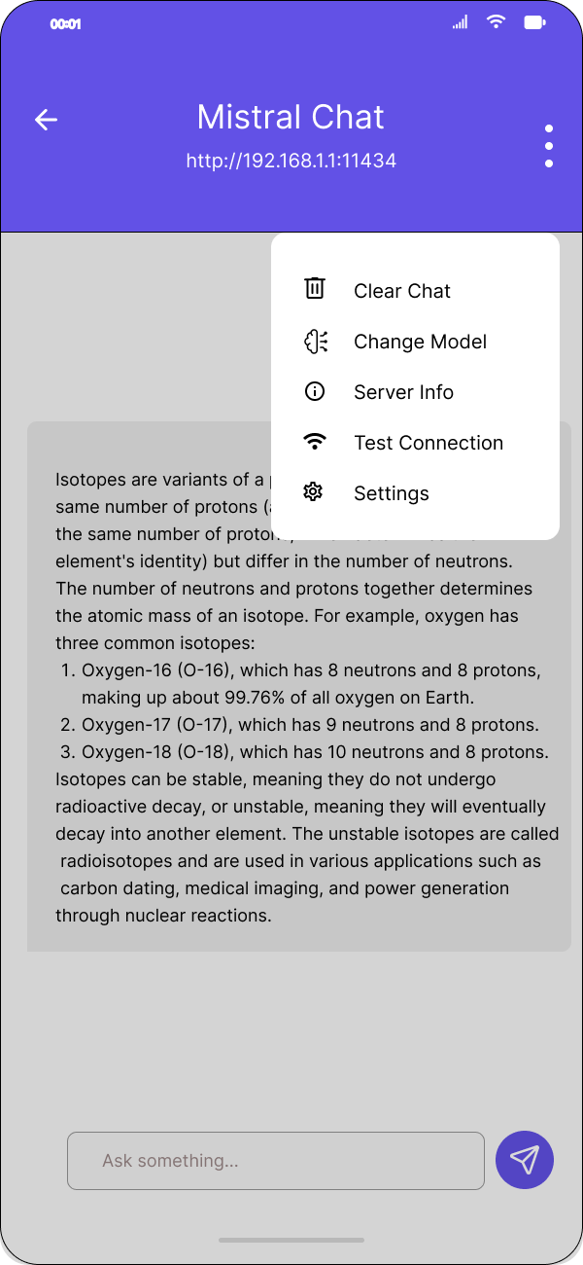

Fig 3.3: Figma - Local Llama Chat Wireframes

Personal Reflection
Prototyping first will speed up development.

Week 4: Event Handling and User Interaction
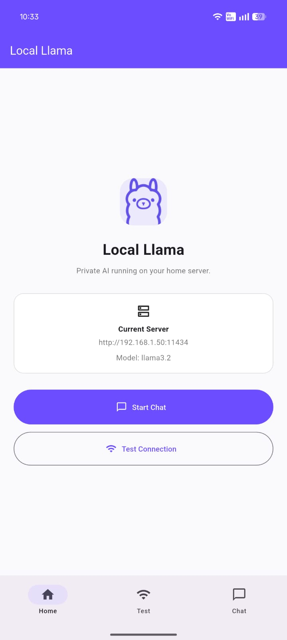
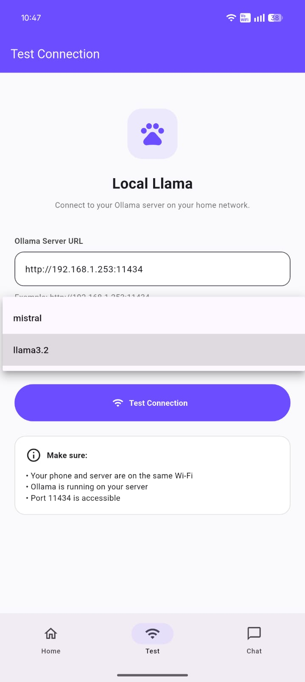

Fig 4.1:Live app - Intuitive navigation Fig 4.2:AI Model selection

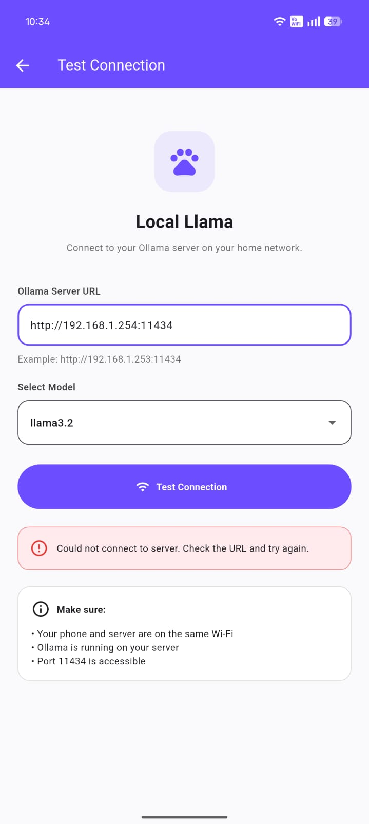
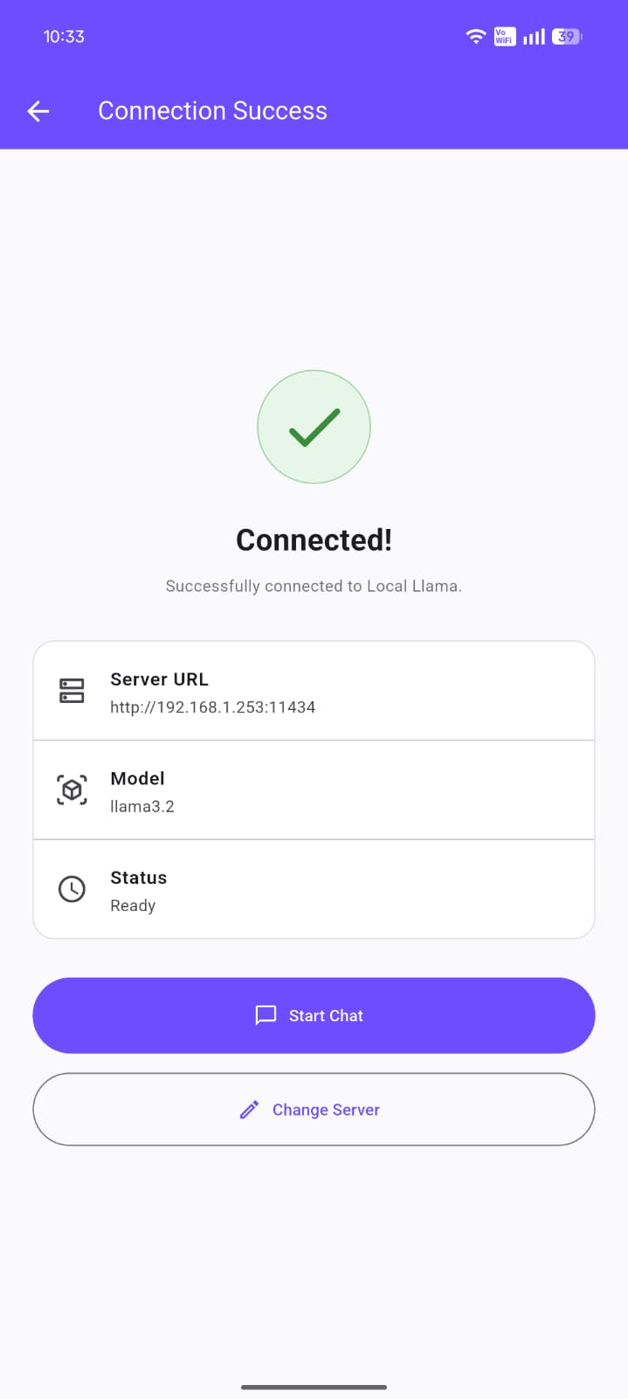

Fig 4.3:Connection event failure Fig 4.4: Connection event success

Week 5: Data Management

Same as week 1

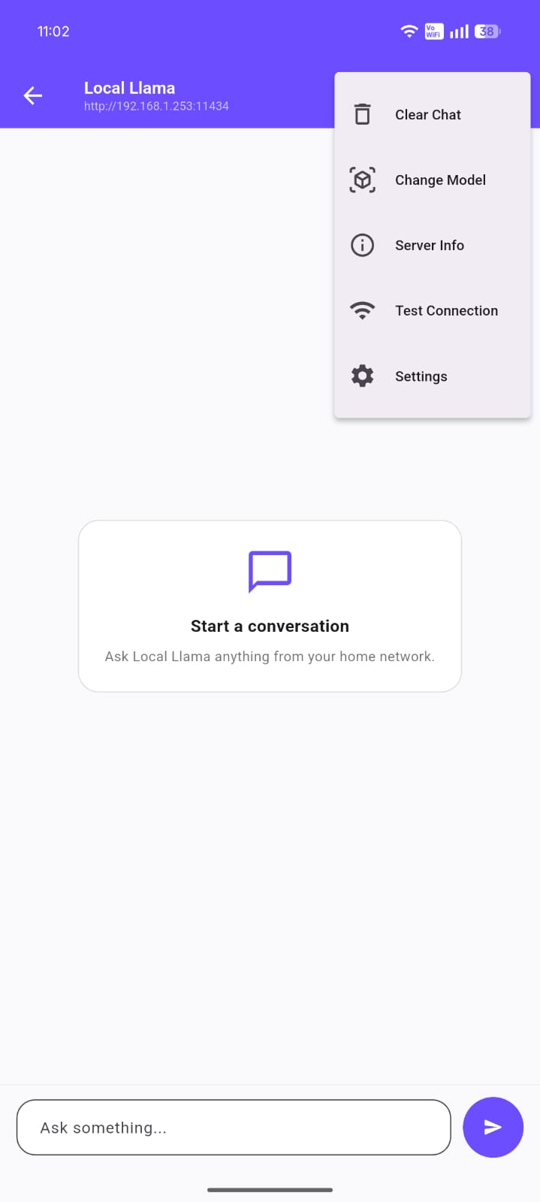
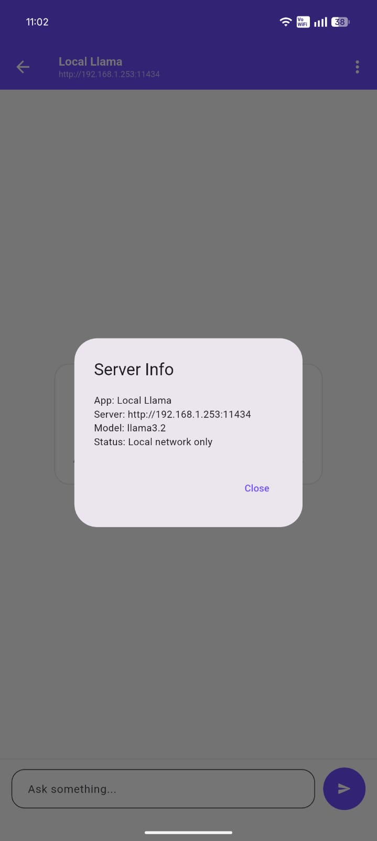

Fig 5.1:App settings data Fig 5.2: Data in shared preferences

Week 6: Networking and APIs

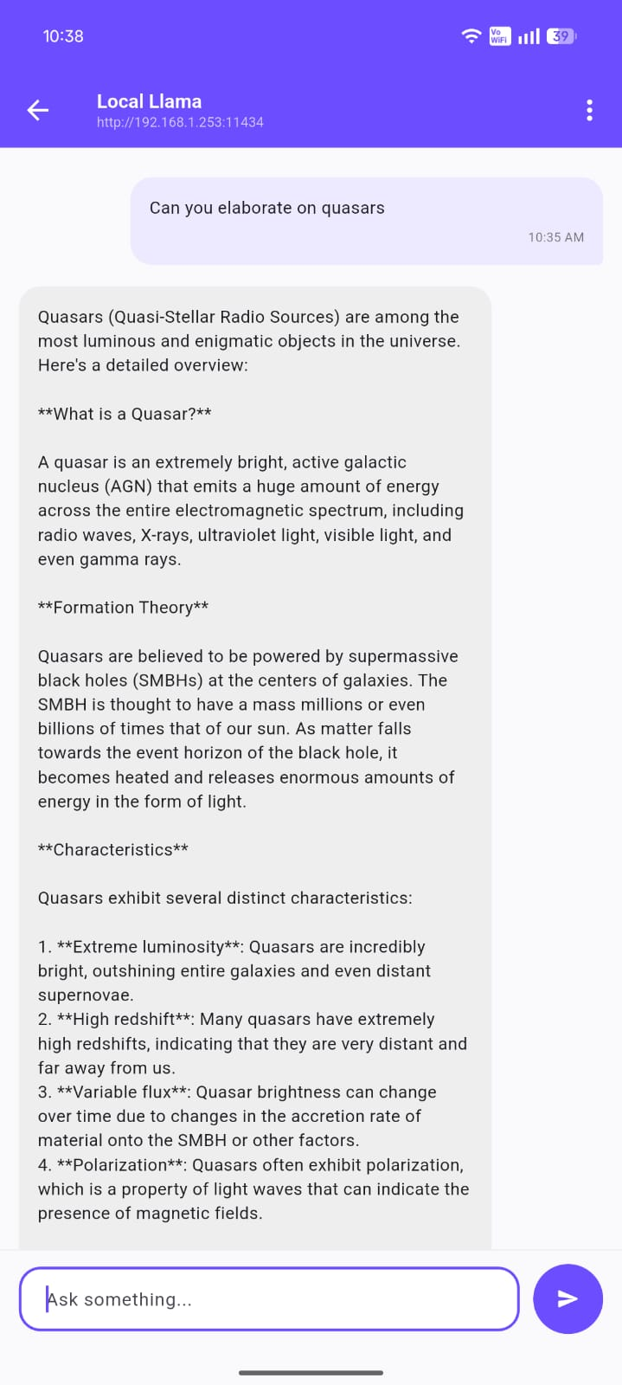
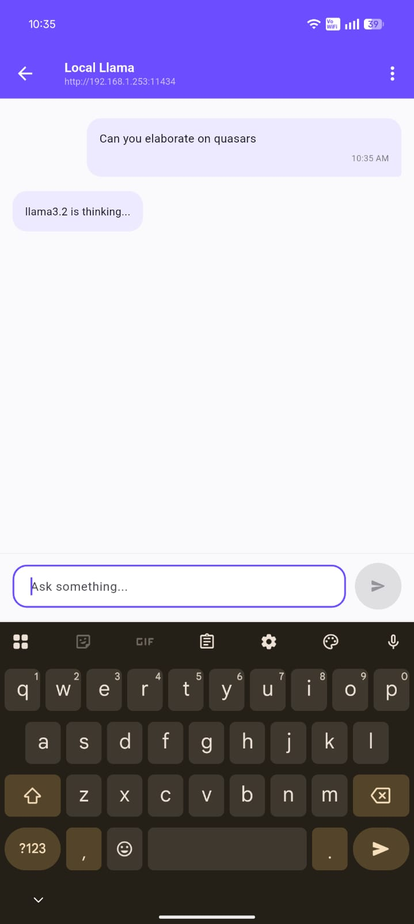

Fig 6.1:POST data to server Fig 6.2: Data received from server

Week 7: Application Architecture
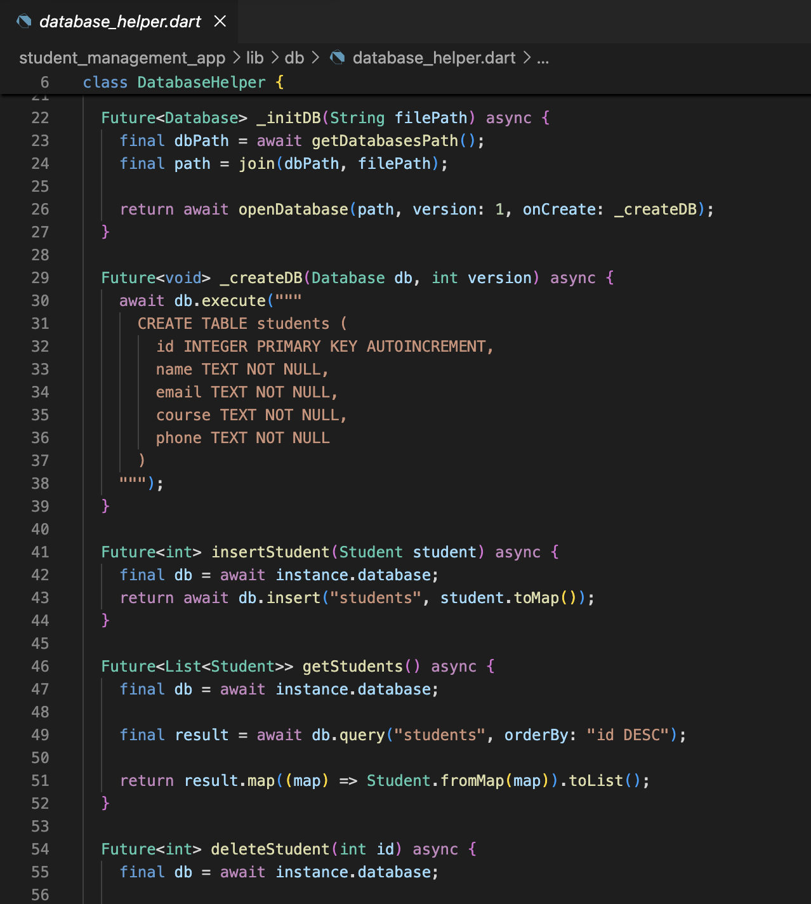

Fig 7.1: SQLite Database setup

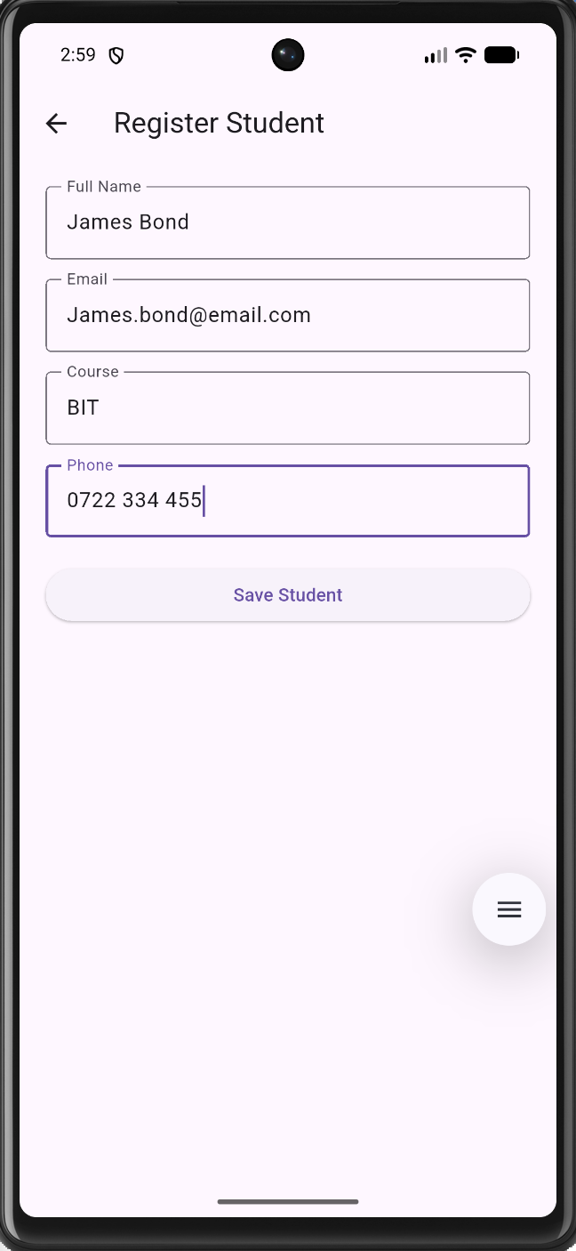
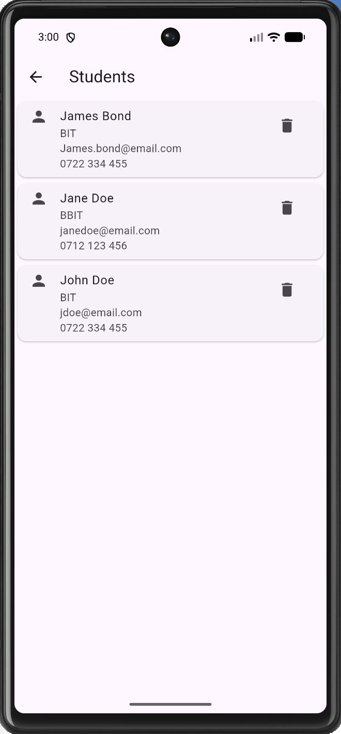

Fig 7.2: Database Add entry Fig 7.2: Database List rows

Week 8: Project Planning

Week 9: Device Features and Sensors

Same as week 1

Week 10: Notifications and Background Services

Same as week 1

Week 11: Mobile Security

Same as week 1

Week 12: Testing and Debugging

Same as week 1

Week 13: Application Deployment

Same as week 1

Week 14: Final Project Presentation

Same as week 1

Semester Project Tracking

Project Title

Project Objectives

Project Requirements

Development Milestones

Testing Results

Lessons Learned

Future Improvements

End of Semester Reflection

Summary of Skills Acquired

Most Interesting Topic

Major Challenges Faced

How Challenges Were Overcome

Professional Growth Achieved

Overall Course Experience

Final Approval
Student Name: __________________________
Student Signature: ______________________
Date: _________________________________
Lecturer Name: _________________________
Lecturer Remarks: _____________________
Date: _________________________________

